**COMET BAY COLLEGE**

**Physics Unit 3 - Task 3**

**Circular Motion Pre-Test**

**Name: SOLUTION Total Marks /15**

**Aim:** To study how force is affected when changing the radius for an object moving in a circular path.

**Hypothesis:** ________________________________________________________________________________________________________________________________________________________________________________________________________________________________________________________________________________________________________________________________________________________________________

**An unbalanced force must act on an object moving in a circular path. This force is inversely proportional to the radius and directly proportional to the velocity squared. Therefore as the radius increases then the force experienced will also increase.**

**The radius of the object moving in a circular path (m)**

**The time to complete 20 rotations (s)**

**The circular motion of the rubber stopper remaining horizontal**

**The same 250 g mass hanging from the bottom of the fishing line**

**Independent Variable:** ____________________________________________________

**Dependent Variable:** ______________________________________________________

**Controlled Variables:** _____________________________________________________

______________________________________________________

**Material:**

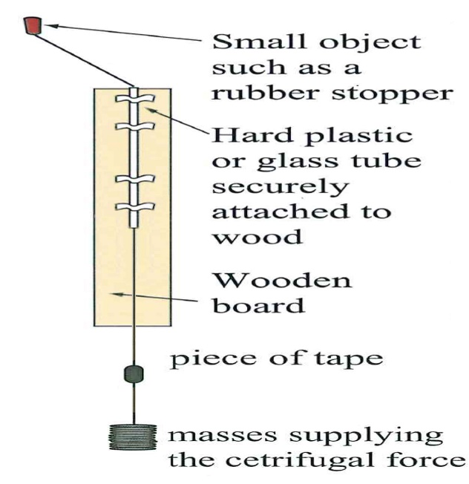

**Figure 1: Set up of apparatus used to verify equilibrium**

|  |  |
| --- | --- |
| * Circular Motion Apparatus (see Figure 1) | |
| * Large rubber stopper * Slotted mass (500 g) * White tape (as a marker) | * Fishing Line * Stop watch |

**Method:**

1. Set up equipment as shown in Figure 1.
2. Place a mass of 250 g on the end of the fishing line.
3. Place the white tape on the fishing line so when it is in line with the bottom of the wooden board, the stopper has a radii of 200 mm of line extending it from the top of the plastic tube.
4. Whirl the stopper horizontally at a speed required to raise the tape to be in line with the bottom of the board.
5. Record the time for 20 revolutions in Table 1.
6. Repeat this for two more trials in Table 1.
7. Repeat the process for Table 2 and Table 3, but change the radii to 300 mm and 400 mm. In each case, keep the 250 g mass on the end of the fishing line unchanged.

**Practical Results:** (6 marks)

**Table 1: Recorded data of stopper revolving with a variable radius.**

|  |  |  |  |  |  |  |  |
| --- | --- | --- | --- | --- | --- | --- | --- |
|  |  | **Time for 20 turns** | | | **Average time per turn (s)** | **Velocity**  **(m s-1)** | **Velocity2**  **(m2 s-2)** |
| **Radius (m)** | | **Trial 1** | **Trial 2** | **Trial 3** |
| **0.2** | | **10.42** | **11.21** | **11.73** | **0.556** | **2.26** | **5.11** |

**Table 2: Recorded data of stopper revolving with a variable radius.**

|  |  |  |  |  |  |  |  |
| --- | --- | --- | --- | --- | --- | --- | --- |
|  |  | **Time for 20 turns** | | | **Average time per turn (s)** | **Velocity**  **(m s-1)** | **Velocity2**  **(m2 s-2)** |
| **Radius (m)** | | **Trial 1** | **Trial 2** | **Trial 3** |
| **0.3** | | **14.80** | **15.08** | **14.70** | **0.743** | **2.54** | **6.44** |

**Table 3: Recorded data of stopper revolving with a variable radius.**

|  |  |  |  |  |  |  |  |
| --- | --- | --- | --- | --- | --- | --- | --- |
|  |  | **Time for 20 turns** | | | **Average time per turn (s)** | **Velocity**  **(m s-1)** | **Velocity2**  **(m2 s-2)** |
| **Radius (m)** | | **Trial 1** | **Trial 2** | **Trial 3** |
| **0.4** | | **17.05** | **19.02** | **18.05** | **0.902** | **2.79** | **7.43** |

**Use v = $\frac{2 π r}{T}$ (1 mark per average turn and 1 mark per velocity2)**

**Table 1: Recorded data of stopper revolving with a variable radius.**

|  |  |  |  |  |  |  |  |
| --- | --- | --- | --- | --- | --- | --- | --- |
|  |  | Time for 20 turns | | | Average time per turn (s) | Velocity  (m s-1) | Velocity2  (m2 s-2) |
| Radius (m) | | Trial 1 | Trial 2 | Trial 3 |
|  | |  |  |  |  |  |  |

**Table 2: Recorded data of stopper revolving with a variable radius.**

|  |  |  |  |  |  |  |  |
| --- | --- | --- | --- | --- | --- | --- | --- |
|  |  | Time for 20 turns | | | Average time per turn (s) | Velocity  (m s-1) | Velocity2  (m2 s-2) |
| Radius (m) | | Trial 1 | Trial 2 | Trial 3 |
|  | |  |  |  |  |  |  |

**Table 3: Recorded data of stopper revolving with a variable radius.**

|  |  |  |  |  |  |  |  |
| --- | --- | --- | --- | --- | --- | --- | --- |
|  |  | Time for 20 turns | | | Average time per turn (s) | Velocity  (m s-1) | Velocity2  (m2 s-2) |
| Radius (m) | | Trial 1 | Trial 2 | Trial 3 |
|  | |  |  |  |  |  |  |

**Questions:**

1. Explain the principles and any background knowledge on the theory of horizontal circular motion. Also consider the principals should the mass be changed rather that the radius. What relationship is there between the hanging mass and the stopper, when the apparatus is in motion?

____________________________________________________________________________________________________________________________________________________________________________________________________________________________________________________________________________________________________________________________________________________________________________________________________________________________________________________________________________________________________________________________________________________________________________________________________________________________________________________________________________________________________________________________________________________________________________________________________________________________________________________________________________________________________________________________________________________________________________________________________________________________________________________________________________________________________________________________________________________________________________________________________________________________________________________________________________________________________________________________________________________________________________________________________________________________________

1. Calculate the expected percentage uncertainty for the results in table 1 only when considering the devices used. (2 marks)

**Use of a stop watch which is at 0.01 second intervals.**

**Use of a ruler which is at 0.001 metre intervals.**

**Calculation is a division, therefore must add percentage uncertainties.**

**Calc % unc for table 1**

$T =\frac{0.005}{(10.42+11.21+11.73)/3} × 100$**= 0.0445 %**

$r =\frac{0.0005}{0.2}× 100$**= 0.25 %**

**Add together 0.0445 % + 0.25 % = 0.2945%**

**NOTE - There is no extra uncertainty added by using averages, or dividing by 10**

**Hence for Table 1: velocity ± 0.295% (1 mark) and radius ± 0.25% (1 mark)**

1. Plot radius versus velocity (include the error bars for 200 g). (2 marks)
2. On the same graph paper, but using a secondary vertical axis plot radius versus velocity squared (include the error bars for 200 g). (2 marks)

**Include the following (minus 1 mark for anything missed)**

* **axis labels**
* **axis units**
* **title**
* **line graph (line of best fit)**
* **error bars**
* **line of best fit cuts through all error bars**
* **scaled on axis incorrectly (i.e 0.7, 1.0, 1.7 intervals, instead of 0.5, 1.0, 1.5 intervals)**
* **incorrect points plotted**
* **using under 50% of area given**
* **2 lines with two y axis**



1. Use the correct graph to determine the centripetal force, Fc. (1 mark)

**Fc = = m $\frac{ v^{2}}{r}$**

**Where m = 0.25 kg and $\frac{ v^{2}}{r}$ is the gradient of the line**

**Use coordinates (0.35,7.1) & (0.23,5.5)**

**Gradient = $\frac{rise}{run}$ = $\frac{7.1-5.5}{0.35-0.23}$ = 13.33 m s-2**

**Fc = 0.25 × 13.33 = 3.33 N (1 mark)**

1. Discuss any errors and how they would affect the results. (2 marks)

**Consider**

**If the string and stopper where not horizontal**

**Look at the controlled variables**

**Consider the instruments used and the error values there.**

**(1 marks for any well explained – 2 marks maximum)**

________________________________________________________________________________________________________________________________________________________________________________________________________________________________________________________________________________________________________________________________________________________________________________________________________________________________________________________________________________________________________________________________________________________________________________________________________________________________________________________________________________________________________________________________________________________________________________________________________________________________________________________________________________________________

1. A major error of this experiment is that the mass is not spinning horizontally. Briefly describe how this can affect the experiment?

**Decreased REAL radius 🡪 Means CALCULATED velocity will be higher than REAL.**

**Because plotted Velocities (X Axis) will be higher than real, Gradient will be lower than real.**

**Because the gradient will be lower than real, the calculated value for the mass of the stopper will also be lower than REAL.**

________________________________________________________________________________________________________________________________________________________________________________________________________________________________________________________________________________________________________________________________________________________________________________________________________________________________________________________________________________________________________________________________________________________________________________________________